System Requirements Statement (SRS) –

Ground Booking System

1. Introduction 3

2. Functional Requirements 4

2.1 Customer Module 5

2.2 Owner Module 11

2.3 admin Module 17

2.4 Use Case Diagram.............................................................................................................................21

THIS DOCUMENT CONTAINS 23 NUMBERED PAGES

# Introduction

The Sports Venue Booking System includes registration of users and ground/court owners, storing their details into the system, providing framework for the users to book sports venue and ground/court owners to view their bookings. The website has the facility to store and provide a digitalized report about the ground/court bookings. It includes a search facility to know the current status of each ground/court available. User can search details of a ground/court using the cities. The sports Venue Booking System can be entered using real conceivable benefits to grounds. Sports Venue Booking System is designed for venue booking for sports Management System and to improve the quality and management online booking. Booking System enables to develop the organization and improve its effectiveness and quality of sports.

# Functional Requirements

The Account part of Ground Booking System has three modules which are divided as described below.

|  |  |  |
| --- | --- | --- |
| **No** | **BRS requirement ID** | **Description** |
| **2.1** | **Customer Module** | |
| **2.1.1** | **F1** | **Account Creation Process** |
| **2.1.2** | **F2** | **Login Process** |
| **2.1.3** | **F3** | **Forgot Password Process** |
| **2.1.4** | **F4** | **Change Password Process** |
| **2.1.5** | **F5** | **Update Account** |
| **2.1.6** | **F6** | **Search Ground** |
| **2.1.7** | **F7** | **Book Ground** |
| **2.1.8** | **F8** | **Cancel Booking** |
| **2.1.9** | **F9** | **View Booking** |
| **2.1.10** | **F10** | **Logout Process** |
| **2.2** | **Owner Module** | |
| **2.2.1** | **F11** | **Account Creation Process** |
| **2.2.2** | **F12** | **Login Process** |
| **2.2.3** | **F13** | **Forgot Password Process** |
| **2.2.4** | **F14** | **Change Password Process** |
| **2.2.5** | **F15** | **Update Account** |
| **2.2.6** | **F16** | **Add Venue** |
| **2.2.7** | **F17** | **Delete account** |
| **2.2.8** | **F18** | **View Bookings** |
| **2.2.9** | **F19** | **Cancel Bookings** |
| **2.2.10** | **F20** | **Logout** |
| **2.3 Admin Module** | | |
| **2.3.1** | **F21** | **Login Process** |
| **2.3.2** | **F22** | **Forgot Password Process** |
| **2.3.3** | **F23** | **Change Password Process** |
| **2.3.4** | **F24** | **Update Account** |
| **2.3.5** | **F25** | **Report Generation** |
| **2.3.6** | **F26** | **Account Management** |
|  | | |

## Customer Module

* Customer is the user of system who wants to book venue.

* He is also able to view the venue.

### Account Creation Process

* Ground Booking System compels to create the account before using it. So Ground Booking System should provide the function which makes customer creates new account.
* When customer creates new account, the function demands four information described as below.

1. Login information
2. Contact Details

* The Login information

The Login information consists of some items described as below.

1. UserID
2. Password
3. First Name
4. Last Name
5. E-mail address
6. User Type
   * All items are compulsory demanded.
   * UserID

* The UserID should be unique. If the UserID correspond with not case-sensitive to other which is previously registered, the UserID should not be registered as an account.
  + Password
* The Password has constrains which makes the Password consists of more than or equal 8 and less than or equal 16 characteristics including characters described as below.

1. Numeric figure (at least one)
2. Capital alphabet (A-Z)(at least one)
3. Small alphabet (a-z)(at least one)
4. Special character (#, $, %, &, etc.) (at least one)

* The Password is masked by dummy characters. The re-entering Password is demanded.
* The Password must be encrypted in Ground Booking System.
  + User Type

The User Type falls into three categories described as below.

1. Customer
2. Owner
3. Admin

The User Type defines also three types of user; " Customer

user", " Owner user", and "Admin user”.

* In an Account Creation Process, the user can select Customer.
* No one could select The Admin, because Admin is implemented to Ground Booking System in advance.
* Contact Details
* The Contact Detail consists of some items described as below.

1. Permanent Address
2. Contact Phone No
   * All items are compulsory demanded.
   * Permanent Address

* Permanent Address should be filled.
* But only the state should be selected from options.
* The Security Question information

The Security Question information is needed when Customer lost their Password. This information consists of two items described as below.

1. Selected Question
2. Answer
   * All items are compulsory demanded.
   * Some questions which are difficult to answer for anyone else are prepared in advance.

E.g. which color do you like most?

* + A question should be selected from options by the customer, and the Answer is registered by the customer.
* Login information should be entered on one screen, and then customer information and Security Question information should be entered on another screen.

### Login Process

* Ground Booking System always compels user authentication before using itself except when a new account is successfully created.
* The user authentication demands UserID and Password. The UserID and the Password should be checked in three ways.
  + First, The UserID and the Password should be existed and correct.
* If The UserID and the Password are not equal to what the user has registered, the user authentication cannot be provided.
  + Second, the User Type linked to the UserID should be "customer".
* When the User Type is "customer", then user can be placed on “customer Home”.
  + Finally, UserID should be available.
* The Admin can decide whether the UserID is available or suspended – Refer to the SRS of the Admin part.
* If customer is rejected, user authentication is not provided for system user.
* The customer account should alive for so long as the duration decided by Admin.
* Only when the three checks are successfully completed, customer can be placed on respected page.
* The “Customer Home” provides the some items described as below.

1. A trigger to login
2. A trigger to update Account
3. A trigger to Change Password
4. A trigger to Search Venue
5. A trigger to Book Venue
6. A trigger to cancel booking
7. A trigger to logout

### Forgot Password Process

* When system user lost their Password, the recovery method should be provided by Ground Booking system.

The recovery method is described as below.

* + First, system user enters their UserID for Ground Booking System.
  + Next, Ground Booking System demands the Answer which has been registered since when the Account was created.
  + Only when the Answer is correct, customer get the new password by E-mail which also has been registered since when the Account was created.
  + The new password is automatically generated by Ground Booking System.
* Of course, the new password should consist of more than or equal 8 and less than or equal 16 characteristics including at least a numeric figure, a capital alphabet, a small alphabet, and a special character.
* As a consequence, The Customer could get the Customer authentication using the new password.
  + Then, the Customer had better change the new password manually.
* If the Answer is not correct, otherwise, the correct Answer is demanded for user again.
  + In that case, Of course, customer couldn’t get the new password.

### Change Password Process

* When customer wants to change their Password, the measure should be provided by Ground Booking System.
* Therefore, Ground Booking System should provide the function which is available after getting the customer authentication.
* The function demands the current password and the new password.
  + Of course, the new password should consist of more than or equal 8 and less than or equal 16 characteristics including at least a numeric figure, a capital alphabet, a small alphabet, and a special character.
  + The current password and the new password are masked by using dummy characters.
  + The new password is demanded to enter twice to avoid a typing error.
* Only when the current password is correct, farmer could change their Password.
* When the current password is changed into new password, Ground Booking System compels user authentication again.

### Update Account Process

* Ground Booking System should provide the function which makes the account updated for customer.
* The information customer could update is described below.

1. Login information
2. User information
3. Security Question Information

* The Login information

The updatable items as described below.

1. First Name
2. Last Name
3. E-mail address
   * All items are compulsory demanded, but updating is optional.

* The User information

The updatable items as described below.

1. User Name
2. User Phone No
3. E-mail address
4. Permanent address
   * All items are compulsory demanded, but updating is optional.

* The Security Question information

The updatable items as described below.

1. Selected Question
2. Answer
   * All items are compulsory demanded, but updating is optional.

### Search venue

* Search conditions are described as below.

1. Venue Category
2. Price range

### Book Venue

* Customer can book venue as per his requirements by searching venue.

### View Booking

* After booking ground the customer can view action.

1. Booked Time.
2. Venue price.

### Cancel Booking

• After booking venue if customer wants to cancel booking then he can cancel the booking.

### Logout

• Customer can logout.

#### Owner Module

### Account Creation Process

* Ground Booking System compels to create the account before using it. So, Ground Booking System should provide the function which makes owner creates new account.
* When owner creates new account, the function demands four information described as below.

1. Login information

2. Contact Details

3. Security Question Information

4. Payment information.

* The Login information

The Login information consists of some items described as below.

5. UserID

6. Password

7. First Name

8. Last Name

9. E-mail address

10. User Type

* + All items are compulsory demanded.
  + UserID
* The UserID should be unique. If the UserID correspond with not case-sensitive to other which is previously registered, the UserID should not be registered as an account.
  + Password
* The Password has constrains which makes the Password consists of more than or equal 8 and less than or equal 16 characteristics including characters described as below.

1.Numeric figure (at least one)

2.Capital alphabet (A-Z)(at least one)

3.Small alphabet (a-z)(at least one)

4.Special character (#, $, %, &, etc.) (at least one)

* The Password is masked by dummy characters. The re-entering Password is demanded.
* The Password must be encrypted in Ground Booking System.
  + User Type

The User Type falls into three categories described as below.

1. Customer
2. Owner
3. Admin
   * The User Type defines also three types of user; " Customer

* user", "Owner user", and "Admin user”.
* In an Account Creation Process, the user can select Owner.
* No one could select The Admin, because Admin is implemented to Ground Booking System in advance.
* Contact Details
* The Contact Detail consists of some items described as below.

1.Permanent Address

2.Contact Phone No

* + All items are compulsory demanded.
  + Permanent Address
* Permanent Address should be filled.
* But only the state should be selected from options.
* The Security Question information

The Security Question information is needed when Wholesaler lost their Password. This information consists of two items described as below.

1. Selected Question
2. Answer
   * All items are compulsory demanded.
   * Some questions which are difficult to answer for anyone else are prepared in advance.

E.g. which color do you like most?

* + A question should be selected from options by the Owner, and the Answer is registered by the Owner.
* Login information should be entered on one screen, and then Owner information and Security Question information should be entered on another screen.

### Login Process

* Ground Booking System always compels Owner authentication before using itself except when a new account is successfully created.
* The user authentication demands UserID and Password. The UserID and the Password should be checked in three ways.
  + First, The UserID and the Password should be existed and correct.
* If The UserID and the Password are not equal to what the user has registered, the user authentication cannot be provided.
  + Second, the User Type linked to the UserID should be "user".
* When the User Type is " Owner ", user can be placed on “Owner Home”.
  + Finally, UserID should be available.
* The Administrator can decide whether the UserID is available or suspended – Refer to the SRS of the Admin part.
* If user is rejected, user authentication is not provided for Owner.
* The Owner account should alive for so long as the duration decided by Admin.
* Only when the three checks are successfully completed, Owner can be placed on respected page.
* The “Owner Home” provides the some items described as below.

1. A trigger to login
2. A trigger to update Account
3. A trigger to Change Password
4. A trigger to Add Venue
5. A trigger to Update Venue Information
6. A trigger to Book venue
7. A trigger to remove venue
8. A trigger to view booking
9. A trigger to logout

### Forgot Password Process

* When owner lost their Password, the recovery method should be provided by Ground Booking system.

The recovery method is described as below.

* + First, owner enters their UserID for Ground Booking System.
  + Next, Ground Booking System demands the Answer which has been registered since when the Account was created.
  + Only when the Answer is correct, owner get the new password by E-mail which also has been registered since when the Account was created.
  + The new password is automatically generated by Ground Booking System.
* Of course, the new password should consist of more than or equal 8 and less than or equal 16 characteristics including at least a numeric figure, a capital alphabet, a small alphabet, and a special character.
* As a consequence, The owner could get the user authentication using the new password.
  + Then, the owner had better change the new password manually.
* If the Answer is not correct, otherwise, the correct Answer is demanded for owner again.
  + In that case, Of course, owner couldn’t get the new password.

### Change Password Process

* When owner wants to change their Password, the measure should be provided by Ground Booking System.
* Therefore, Ground Booking System should provide the function which is available after getting the owner authentication.
* The function demands the current password and the new password.
  + Of course, the new password should consist of more than or equal 8 and less than or equal 16 characteristics including at least a numeric figure, a capital alphabet, a small alphabet, and a special character.
  + The current password and the new password are masked by using dummy characters.
  + The new password is demanded to enter twice to avoid a typing error.
* Only when the current password is correct, owner could change their Password.
* When the current password is changed into new password, Ground Booking System compels owner authentication again.

### Update Account Process

* Ground Booking System should provide the function which makes the account updated for owner.
* The information owner could update is described below.

1. Login information

2. User information

3. Security Question Information

* The Login information

The updatable items as described below.

1. First Name
2. Last Name
3. E-mail address
   * All items are compulsory demanded, but updating is optional.

* The User information

The updatable items as described below.

1. User Name
2. User Phone No
3. E-mail address
4. Permanent address
   * All items are compulsory demanded, but updating is optional.

* The Security Question information

The updatable items as described below.

1. Selected Question
2. Answer
   * All items are compulsory demanded, but updating is optional.

#### Add Venue

The owner can add grounds in the Ground booking system and make them available for the users.

#### Remove Venue

The owner can remove grounds from the Ground booking system if he/she want to remove it.

**2.2.8 Payback Process**

• In payback process system following are the conditions

1. If somehow order is not fulfil.

2. If owner is not able to provide service.

**2.2.9 Cancel Order**

Owner can cancel the order in following condition

1. If the ground does not fulfil the requirement of customer.

2. In case of violations of rules.

Browse existing ground Price

• Owner could see the information of existing grounds**.**

#### Admin Module

**•** Adminshould be responsible for following activities**,**

### Login Process

* Ground Booking System always compels user authentication before using itself except when a new account is successfully created.
* The user authentication demands UserID and Password. The UserID and the Password should be checked in three ways.
  + First, The UserID and the Password should be existed and correct.
* If The UserID and the Password are not equal to what the admin has registered, the Admin authentication cannot be provided.
  + Second, the User Type linked to the UserID should be "Admin".
* When the User Type is "Admin", user can be placed on “Admin Home”.
  + Finally, UserID should be available.
* The Administrator can decide whether the UserID is available or suspended – Refer to to
* .the SRS of the Admin part.
* If user is rejected, user authentication is not provided for system user.
* The Admin account should alive for so long as the duration decided by Admin.
* Only when the three checks are successfully completed, Admin can be placed on respected page.
* The “Admin Home” provides the some items described as below.

1. A trigger to login
2. A trigger to Change Password
3. A trigger to View Grounds
4. A trigger to View Bookings
5. A trigger to View Owners
6. A trigger to View users
7. A trigger to Delete Owner
8. A trigger to Delete User
9. A trigger to Remove Venue
10. A trigger to logout

### Forgot Password Process

* When Admin lost their Password, the recovery method should be provided by Ground Booking system.

The recovery method is described as below.

* + First, Admin enters their UserID for Ground Booking System.
  + He will enter the E-mail id since when the Account was created.
  + Only when the E-mail Id is correct, Admin get the new password by E-mail which also has been registered since when the Account was created.
  + The new password is automatically generated by Ground Booking System.
* Of course, the new password should consist of more than or equal 8 and less than or equal 16 characteristics including at least a numeric figure, a capital alphabet, a small alphabet, and a special character.
* As a consequence, The Admin could get the Admin authentication using the new password.
  + Then, the Admin had better change the new password manually.

### Change Password Process

* When Admin wants to change his Password, the measure should be provided by Ground Booking System.
* Therefore, Ground Booking System should provide the function which is available after getting the Admin authentication.
* The function demands the current password and the new password.
  + Of course, the new password should consist of more than or equal 8 and less than or equal 16 characteristics including at least a numeric figure, a capital alphabet, a small alphabet, and a special character.
  + The current password and the new password are masked by using dummy characters.
  + The new password is demanded to enter twice to avoid a typing error.
* Only when the current password is correct, Admin could change his Password.
* When the current password is changed into new password, Ground Booking System compels user authentication again.

### Update Account Process

* Ground Booking System should provide the function which makes the account updated for Admin.
* The information Admin could update is described below.

1. Login information
2. User information
3. Security Question Information

* The Login information

The updatable items as described below.

1. First Name
2. Last Name
3. E-mail address
   * All items are compulsory demanded.
4. User Name
5. User Phone No
6. Permanent address
   * These are not compulsory.

* The Security Question information

#### Record Generation

• Admin should able to see all the records from any users.

• Daily report of enrolment to admin.

• Monthly report of enrolment as per the states to admin.

#### Accounts Management

• Admin should able to manage all the accounts with following activities,

1. Enable accounts

2. Disable accoun

#### 2.4 Use Case Diagram

**Admin:**

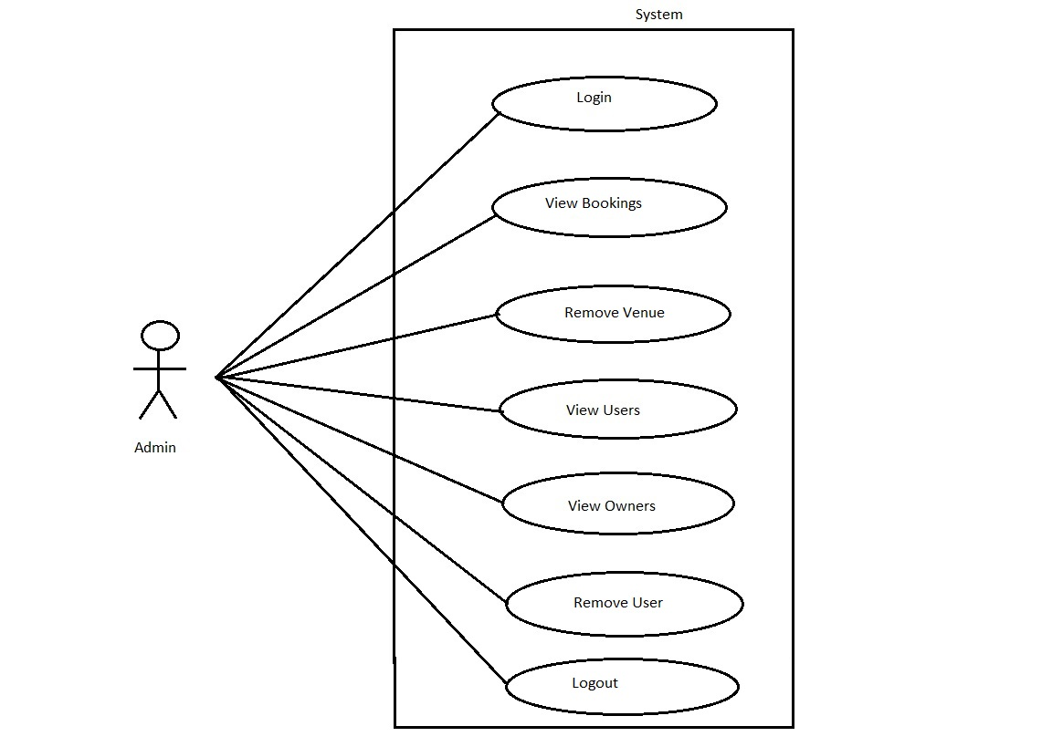

*Fig. Use case diagram for admin*

1. In Admin use case diagram Admin is the Actor.
2. Admin can handle following use cases:
3. Login
4. Report Generation
5. Controls account

**Owner:**

1. In owner use case diagram owner is the Actor.
2. Owner can handle following use cases:
3. Register
4. Login
5. Add Venue/ground
6. Add Venue/Court
7. View Bookings
8. Logout

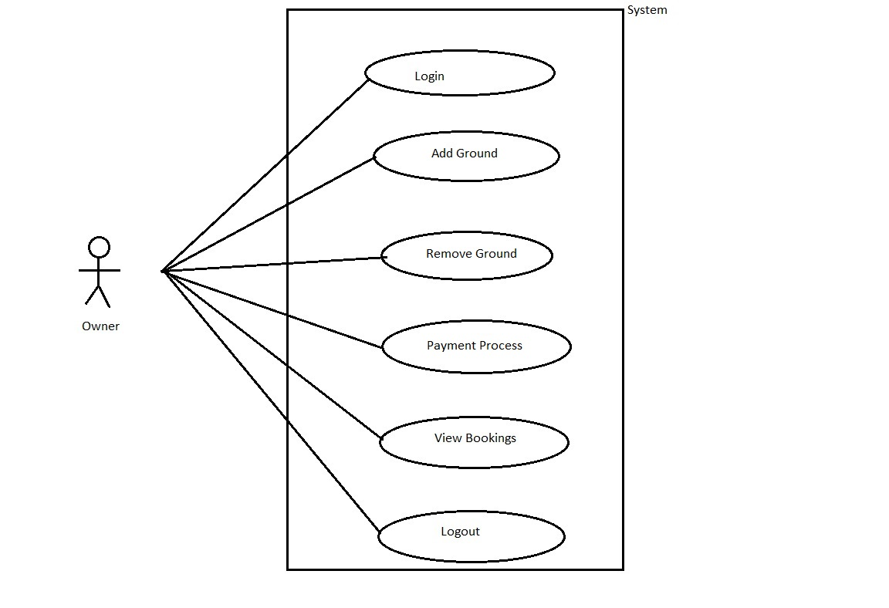

*Fig. Use case diagram for owner*

**Customer:**

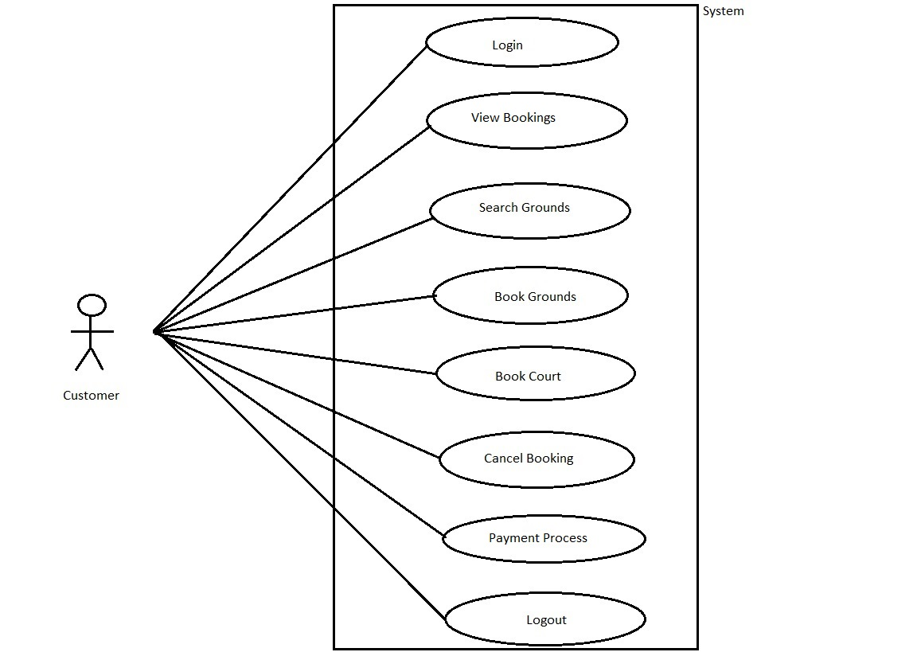

*Fig. Use case diagram for* Customer

1. In Customer use case diagram Customer is the Actor**.**
2. Customer can handle following use cases:
3. Register
4. Login
5. Search Venue
6. Book Ground
7. Book Court
8. Cancel Booking
9. Actions
10. Logout